Laravel Installation Process:

1. Open gitbash from desired Laravel installation folder.

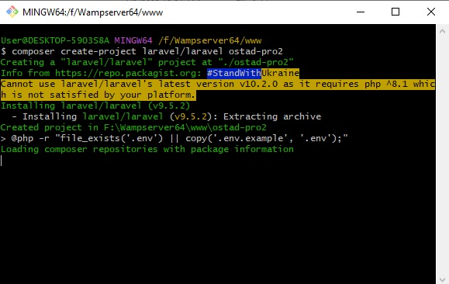

1. Run the command “composer create-project Laravel/Laravel ostad-pro2”
2. The run the command “php artisan serve” to run server

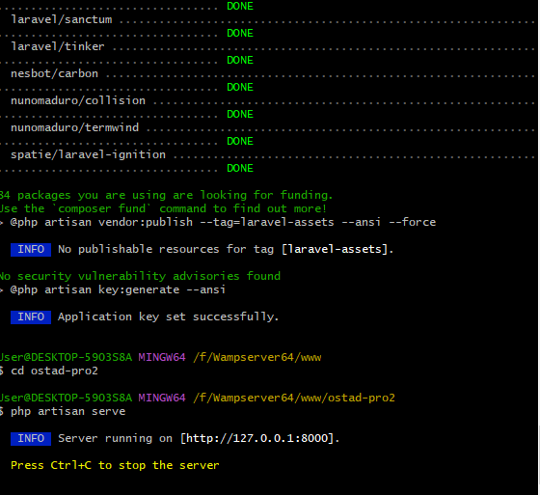

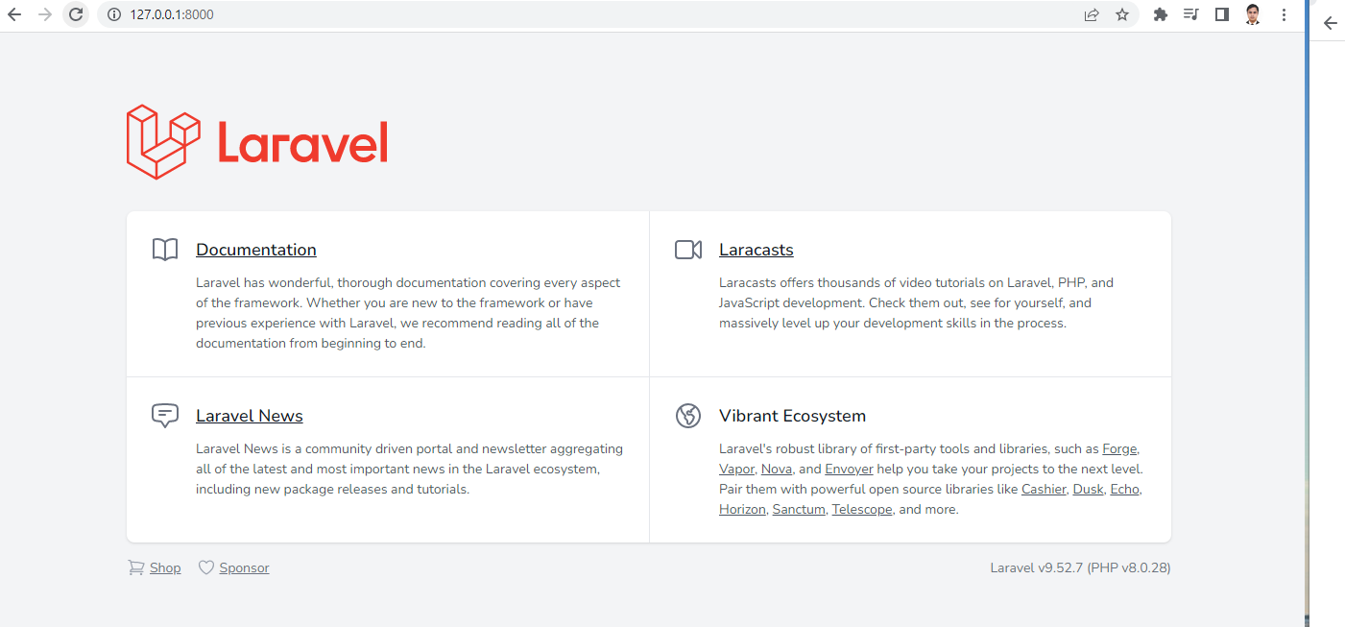

1. Creating simple route

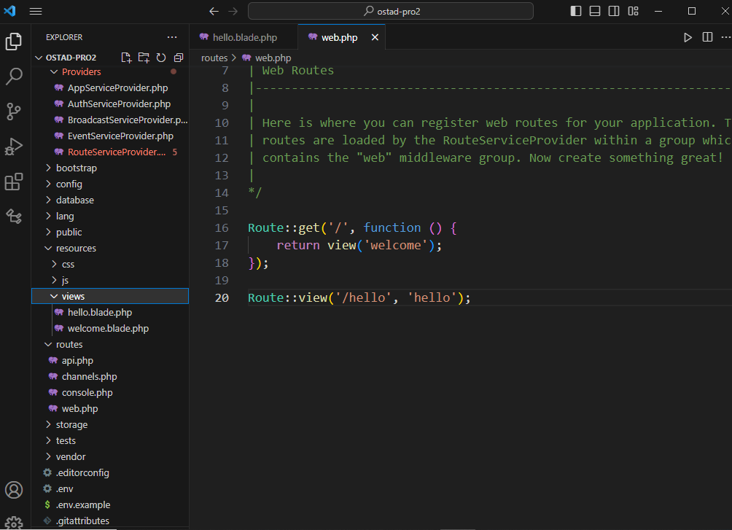

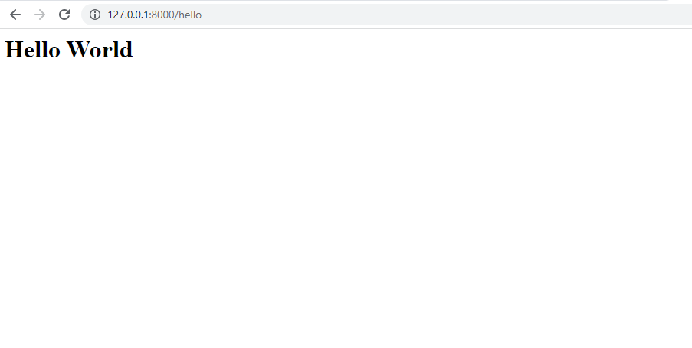

Laravel Folder Structure:

**App:** “App” folder contains the core code of the application. Almost all the classes of the application will be in this directory.

**Bootstrap:** This directory contains app.php file which bootstrap the framework. and there is another directory called cache which contain framework generated files. Usually, no need to modify these files during development.

**Config:** This directory contains all application configuration related files. Its important familiarize with these files to know all the options available for us to develop application.

**Database:** By the name of directory we might understand that it contains database related files such as model and seeds. This directory holds SQLite databases.

**Public:** The public directory contains index.php which is the entry point of all requests entering your application. This directory also holds other folders such as images, JavaScript and CSS.

**Resources:** This directory have a folder called “views” together with other folder called css and JavaScript.

**Routes:** The route directory contains all the path or url structure of the application. This directory contains some important files such as web.php, api.php, console.php.

**Storage:** The storage directory contains our application logs, compiled blade template, file-based session, file caches, and other files generated by the framework.

**Tests:** The tests directory contains your automated tests. Example PHPUnit unit tests and feature tests are provided out of the box. You may run your tests using the php artisan test Artisan command.

**Vendor:** This directory contains Composer dependencies.